


Social /Mental Health Worker
Full Time | GOS – Carnarvon
Salary: G4.1 – G4.3 ($76,768 – $82,027)
Gascoyne Outreach Service (GOS), part of Geraldton Regional Aboriginal Medical Service (GRAMS), is seeking a qualified and experienced Social Worker / Mental Health Professional to join our Social Emotional Wellbeing team.

Position Purpose

To provide comprehensive assessments, care planning and clinical support to Social Support Service clients, delivering culturally safe and trauma-informed mental health services within a multidisciplinary primary healthcare setting. The role coordinates holistic, community-based care and works collaboratively with government, non-government and community stakeholders to strengthen access, continuity and culturally responsive support across the Gascoyne region, in alignment with GRAMS’ mission.

Key Responsibilities
- Provide assessment, treatment, crisis intervention and referral to individuals, families, and community members.
- Act as case manager for allocated clients
- Maintain accurate and legally compliant clinical case notes and outcome data.
- Participate in multi-disciplinary case reviews and care planning.
- Liaise with Psychiatrists, GPs, and other health professionals regarding client care.
- Contribute to service development, planning, evaluation, and continuous quality improvement.
- Promote mental health education within community and partner agencies.
- Adhere to the Mental Health Act 2014 and relevant legislation.

Essential Requirements
- Relevant tertiary qualification in Social Work, Psychology, Sociology, or related field
- Current registration in Western Australia (where applicable)
- Experience working with Aboriginal and/or Torres Strait Islander clients.
- Strong knowledge of community mental health principles and the Mental Health Act 2014
- Demonstrated ability to work independently and within a multidisciplinary team.
- Unrestricted “C” Class Driver’s Licence
- Ability to obtain National Police Clearance and Working With Children Check
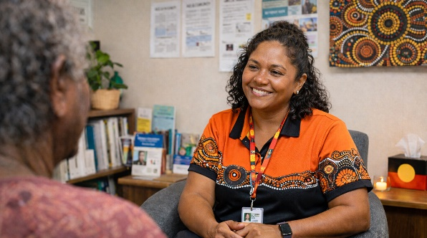
Aboriginal and Torres Strait Islander people are strongly encouraged to apply.
For further information or to request an application package, please contact:
📧 hr@grams.asn.au | iloi.vaqewa@gos.asn.au
📞 (08) 9947 2200.

