
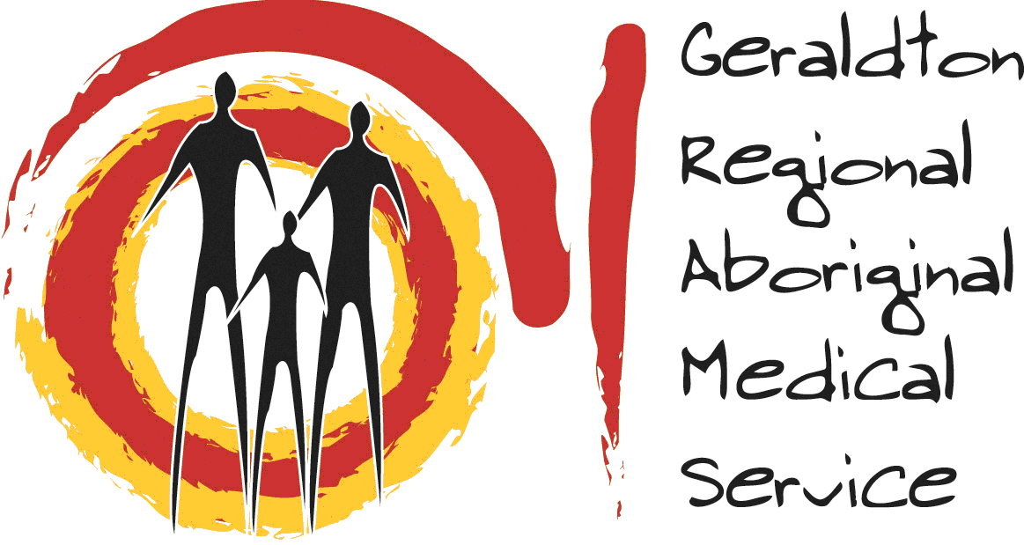
Aboriginal Community Engagement Officer - Youth

"Connecting with Youth, Building Stronger Communities – Join GRAMS."

Location: Carnarvon
Position Type: Full-Time (38hrs per week)
Contract Type: Ongoing
Join Geraldton Regional Aboriginal Medical Service (GRAMS) in making a real difference to the lives of Aboriginal youth in Carnarvon. We are seeking a motivated Community Engagement Officer – Youth to strengthen connections, promote services, and support young people in accessing health and wellbeing programs.
Key Responsibilities:
- Plan and deliver culturally appropriate programs for Aboriginal youth.
- Promote youth engagement in GRAMS activities.
- Liaise with community leaders and service providers to address youth health and wellbeing.
- Advocate for youth needs and identify service gaps.
- Represent GRAMS at local events.
Essential Requirements:
- Diploma/Cert IV in Youth Work, Health Promotion, Community Health, or related field.
- Strong communication and community engagement skills.
- Knowledge of Aboriginal culture and health issues.
- Current driver’s license, National Police Clearance, Working with Children Check (or ability to obtain).
Desirable:
Aboriginal Health qualifications and/or experience working with Aboriginal communities.
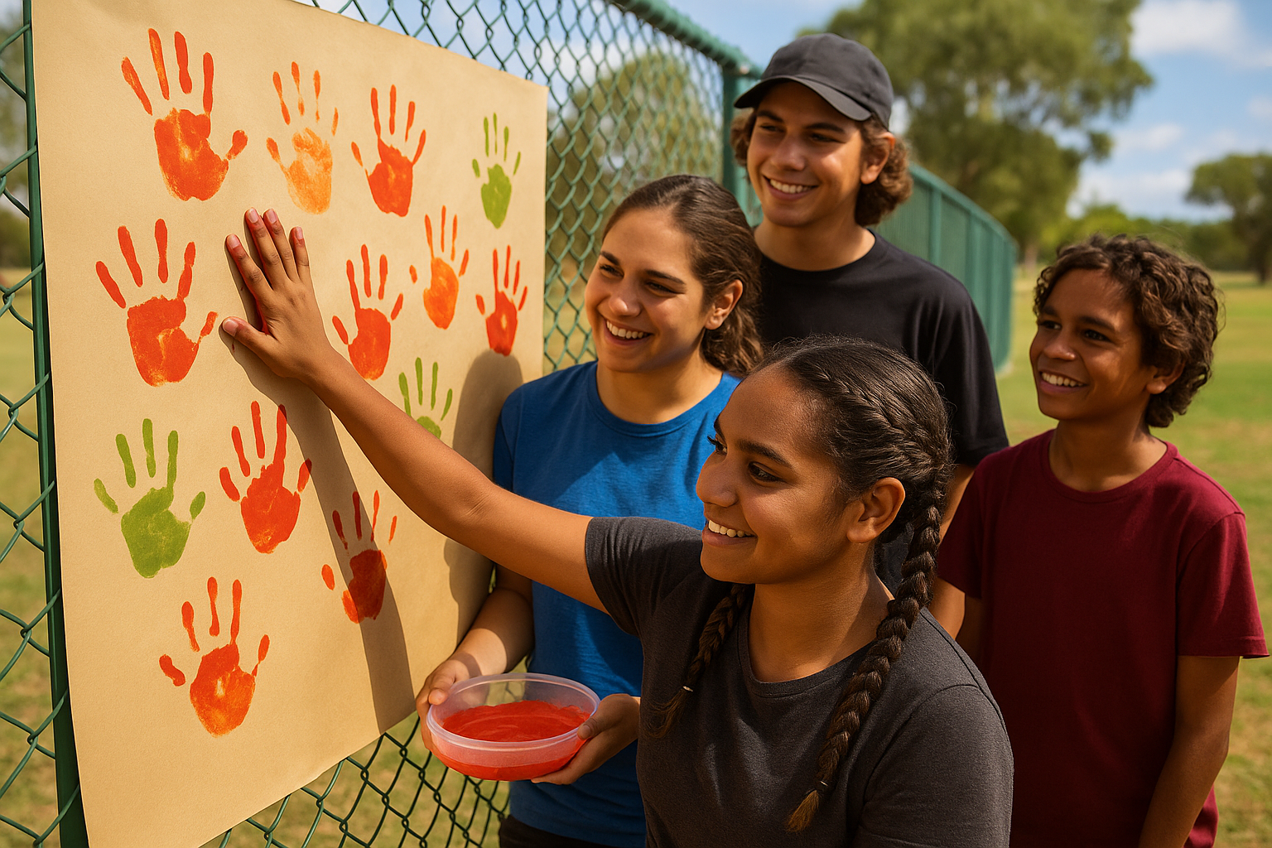
GRAMS offers a supportive, culturally rich work environment where your passion for engaging and empowering youth directly contributes to healthier, stronger communities.
For further information or to request an application package, please contact GRAMS HR at:
Email: hr@grams.asn.au - Contact Iloi Vaqewa at iloi.vaqewa@gos.asn.au
Phone: (08) 9947 2200
Closing Date: 16 May 2026

